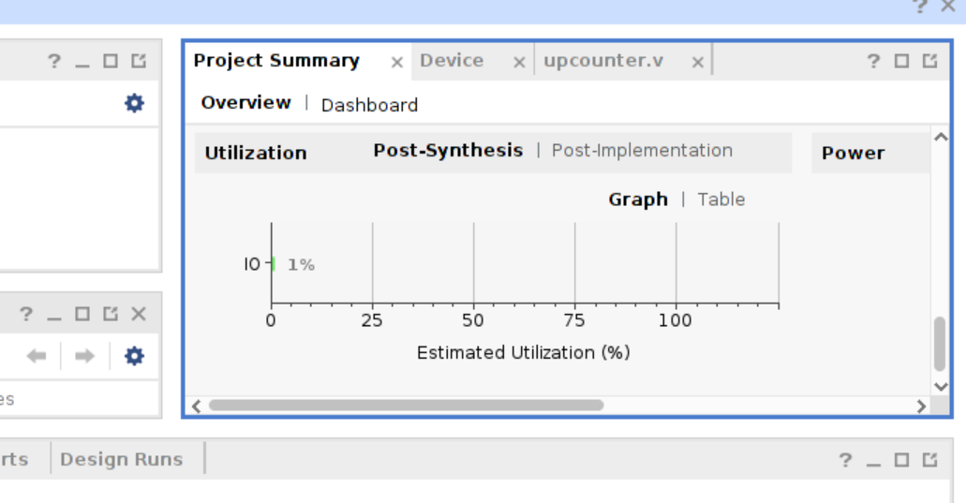

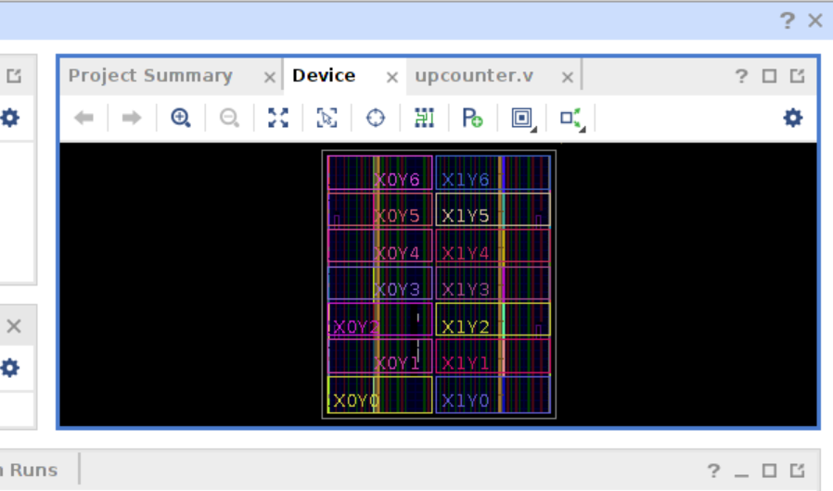

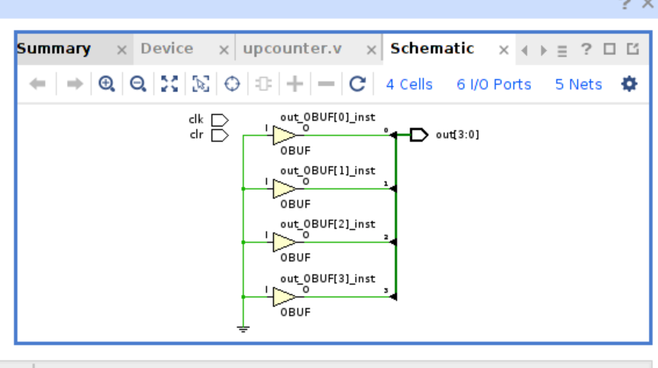

module upcounter(

clk,

clr,

out );

input clr,clk;

output reg [3:0] out;

reg [25:0]temp;

reg clk_div;

always@(

posedge clk)

begin

if(!clr)

begin

temp=0;

clk_div<='d0;

out<='d0;

end

else

begin

temp<=temp+26'd1;

clk_div<=temp[20];

end

end

always@(posedge clk_div)

begin

if(!clr)

out<=4'b0;

else

out<=out+4'd1;

end

endmodule

